Home Section
- The 155MW+ figure refers to Hybrid capacity.
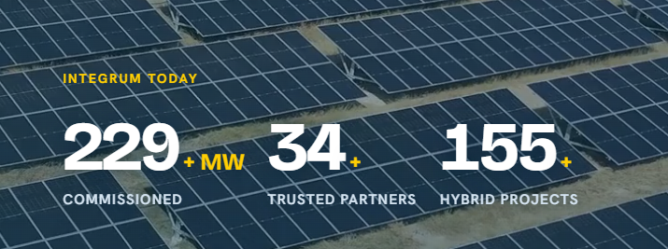
- Remove the Calculator from all pages, as it is not yet complete; the launch is planned separately.
- Below the 25Yr stat, remove the word “Own” (retain “we run”); for the 24*7 stat, remove the word “Guarantees” next to SLA; for the 70-80% stat, change the tagline below it to read “Of replacement of power demand.”
- Change “Trusted by Industrial Leaders” to “Trusted by Segment Leaders.”
- Add the following: a leading water tanks and pipes manufacturer, a woven packaging manufacturer, a cement manufacturer, and a leading jewellery retailer.
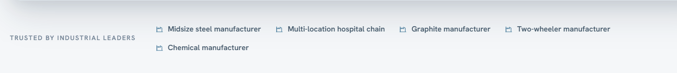
- The “Cut the Energy Bill” link currently points to the savings chart. Since the calculator is being removed, this should instead link to the “Talk to an Advisor” contact page.

- In the chart, the DISCOM line shows a slight decrease and has a different shape than intended; this needs correction. Additionally, 24-hour generation data for solar and wind should be added.
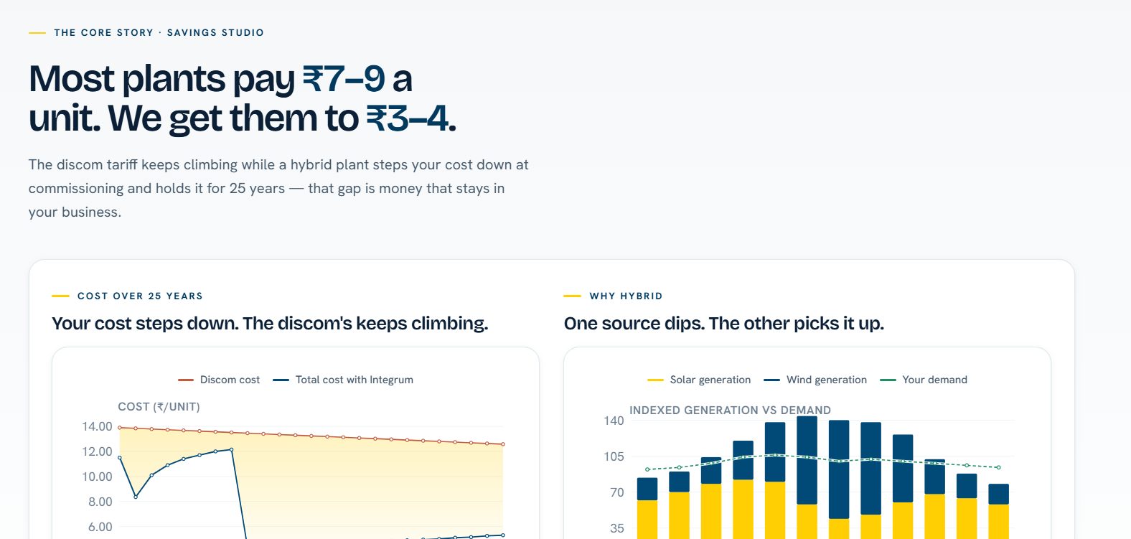
- “Increase My Renewable Energy” should link to the Solutions page covering Capex, Opex, and EaaS.
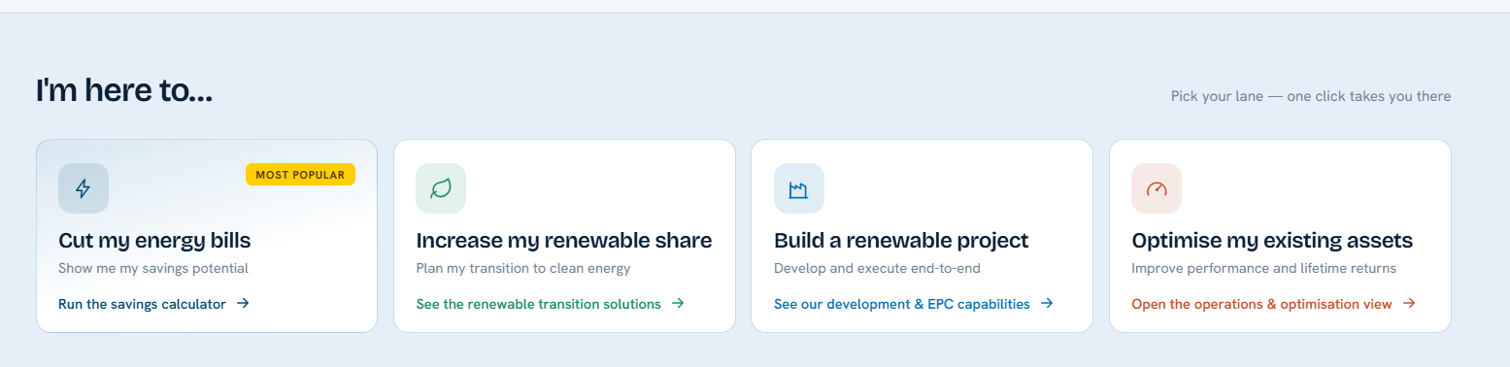
- After the full stop, the word “Build” should start on the second line.

- Change the logo for “Decarbonise On-Site.”
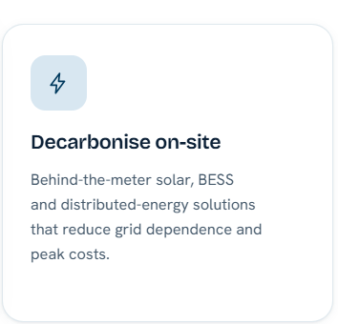
- The spacing between sections on the Home page is too large; reduce it.
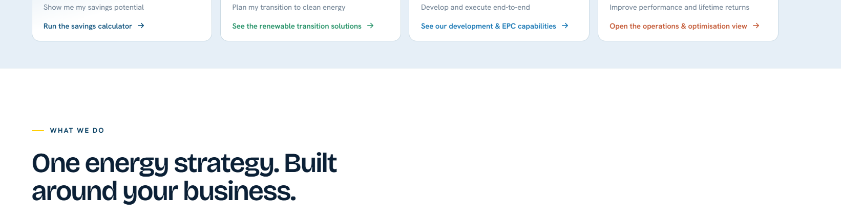
- In the case studies section on the Home page:
  - For Graphite: the cost outcome should read “₹60 Cr. EBITDA Savings,” and the performance outcome should state only that 20% of RE depends on banking.
  - For Steel: the outcome should read “From 0% RE to 100% RE”; performance should read “One of the lowest electricity costs.” Replace the steel-related image with a photo of an actual steel plant.
  - For the hospital chain: change the “90-95% renewable replacement” figure (specific to Karnataka) to “85% overall.”
  - For Two-Wheeler: the cost outcome should read “Reduction of transmission charges by Rs. 30 lakhs p.a.” Change the renewable outcome to “Hybrid with optimised evacuation.” Remove the “175%” figure, as it may be misleading.
For all these changes, the corresponding case study detail page must also be updated.
Consider removing the em dash throughout.
- Remove the SPARK Framework section from the Home page.
Solutions
- After the full stop, “Build” should start on the second line.
- We need a separate, dedicated contact form for customers, distinct from the generic form currently on the Contact Us page.
This dedicated form should capture Industry, Average Annual Consumption, Location, and State details. Any “Talk to an Energy Advisor” or “Bring Us Your Energy Challenge” link on the Solutions or Platform pages should route to this dedicated form, which should sit at the end of the Platform page, replacing the content currently there. A generic contact form can be retained elsewhere as “Join Us in Our Journey.”
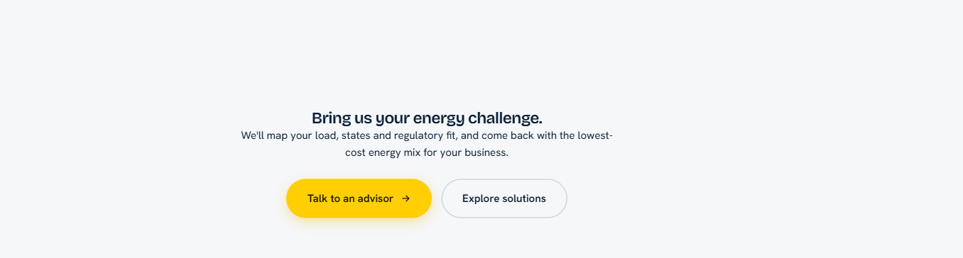
- The Calculator should be removed from the Solutions page as well; its space should instead include Solar, Wind, and Hybrid content.
- The spacing between sections is too large throughout the Solutions and Platform pages.
- A dividing line, centred, could separate these sections.
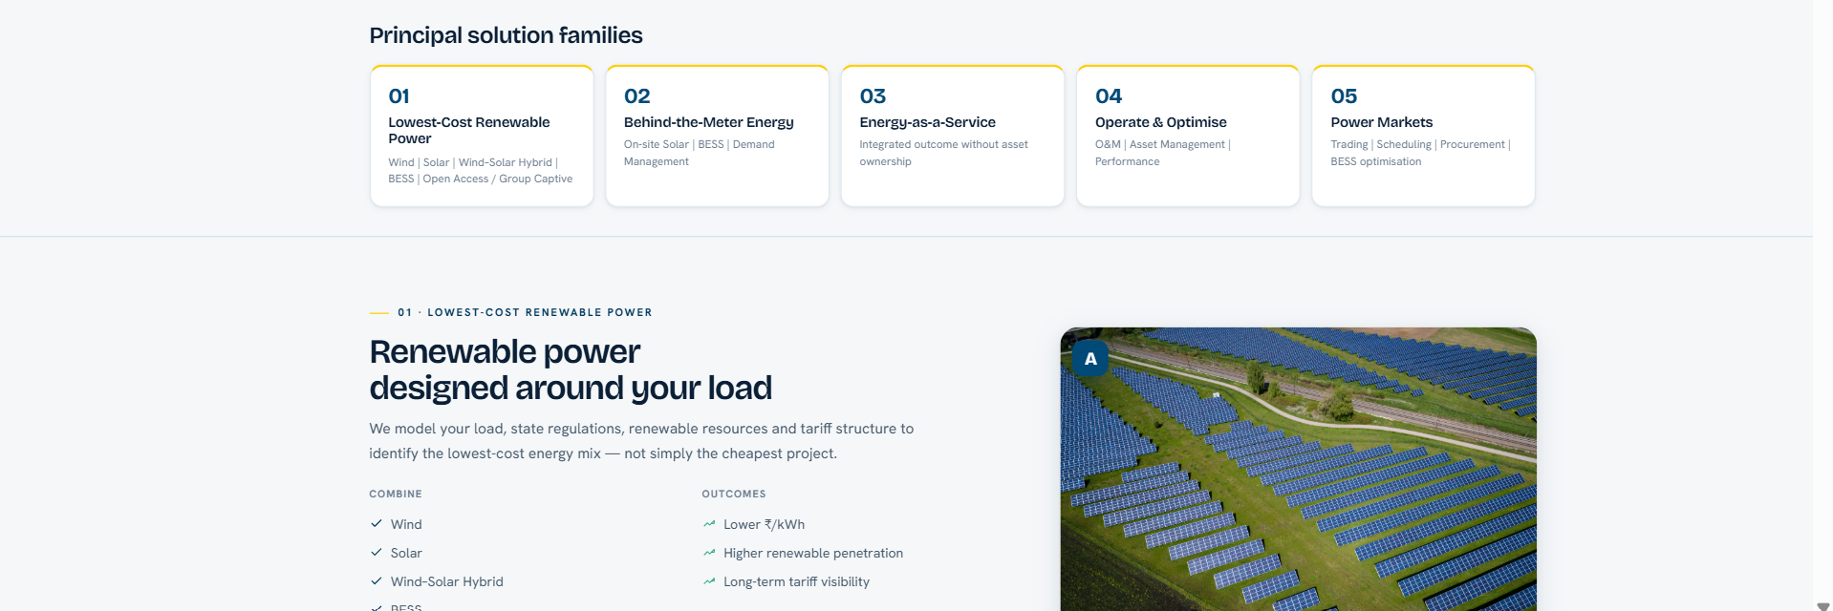
- Remove the A, B, C, D, E labels under each section image.
- This image needs to be changed.
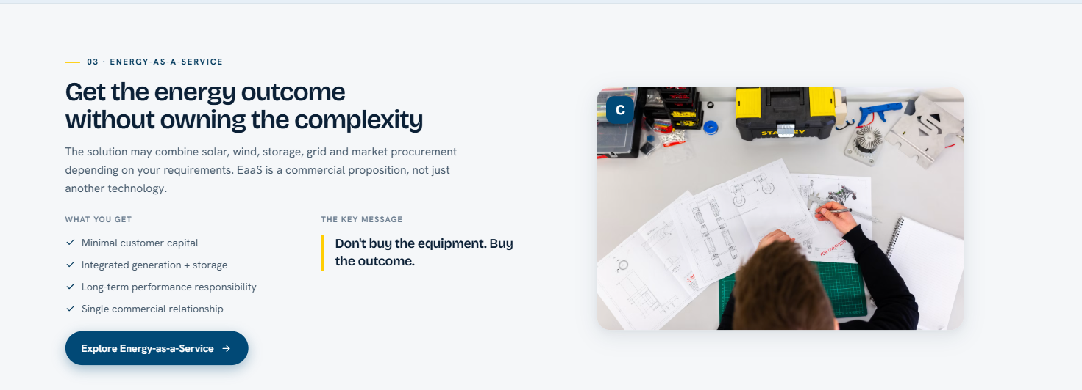
- Reduce the spacing between sections here as well.
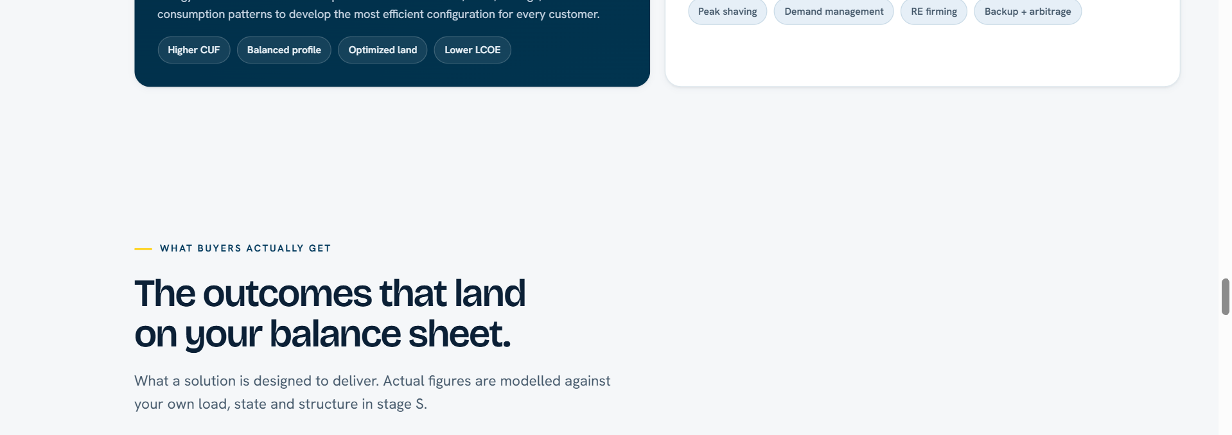
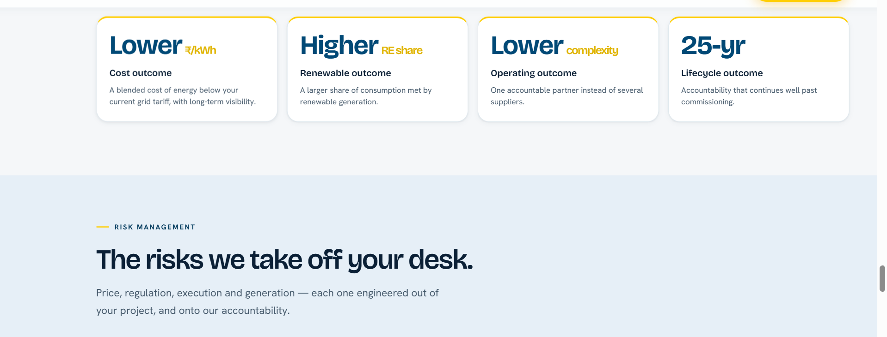
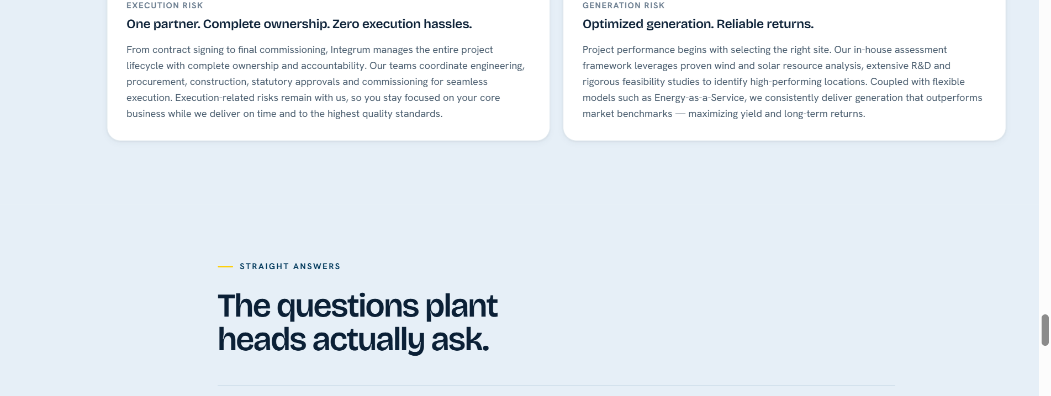
There is excess spacing in several other places too.
Platform
- The sentence “A renewable project is not an isolated asset. Land, connectivity, financing, generation, operations and market procurement all determine the final cost of energy. Integrum brings these decisions onto one platform.” should be placed inside the blue area, so the section below appears with a minimal white intersection separating the data.
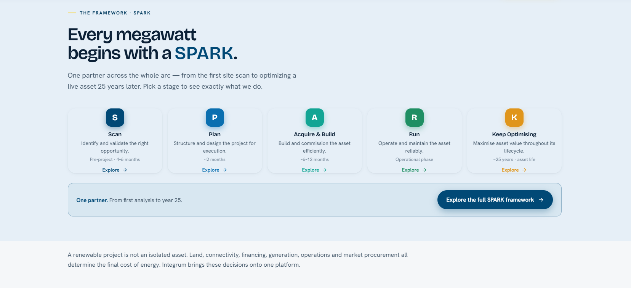
- Replace the specific case example with the layout shown in the attached image below.
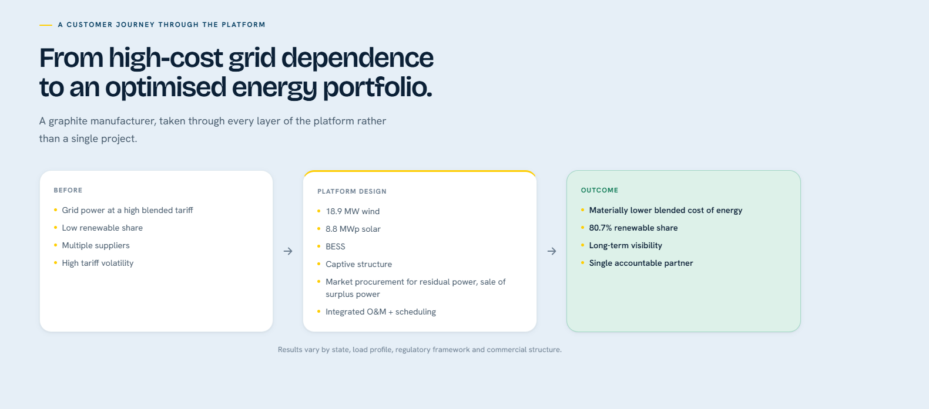
A generic layout can be used instead, as shown in the image below.
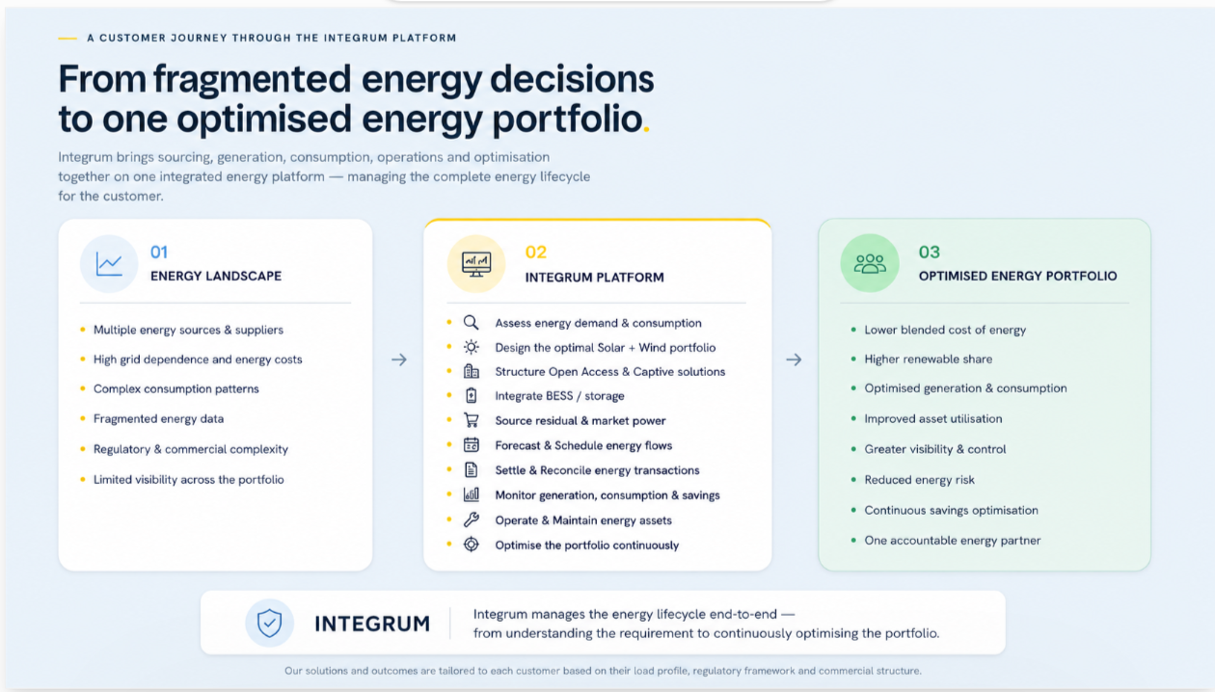
- Reduce the spacing here as well, to keep section spacing consistent across the website.
- The generic customer case above should link across to the specific case study.
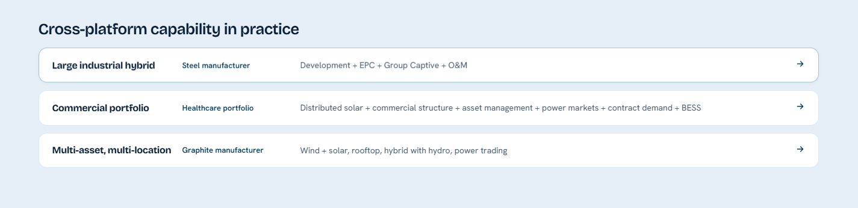
- Show the platform analytically using mockups, with the image placed on the right in this section, using the light theme.
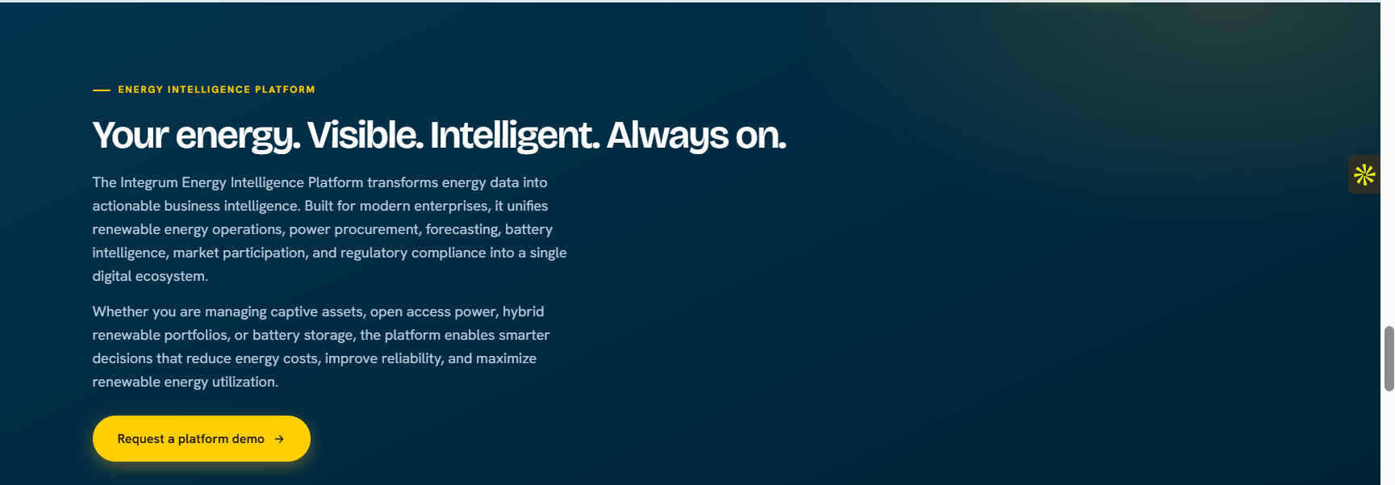
- The word “Complete” should start on the next line.
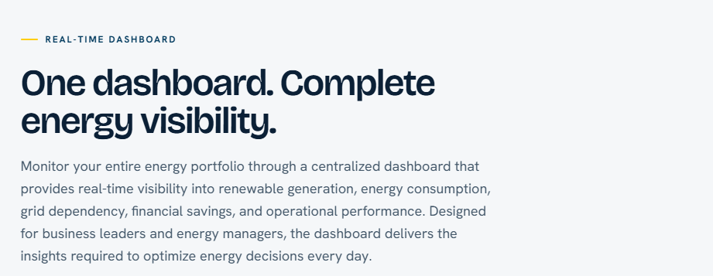
- The “Bring Us Your Energy Challenge” CTA should link to the end of the page — the dedicated section for capturing customer details described in point 2 of the Solutions feedback.
- The full address should be included under the Contact Us tab.
- The spacing between sections under the Platform tab is excessive; reduce it.
- Replace “COD” with “Accountability Doesn’t Stop at Commissioning.”
- In the 3-4 places where “EPC” appears, change it to “Projects.” Also remove the word “EPC” from the Investor section.
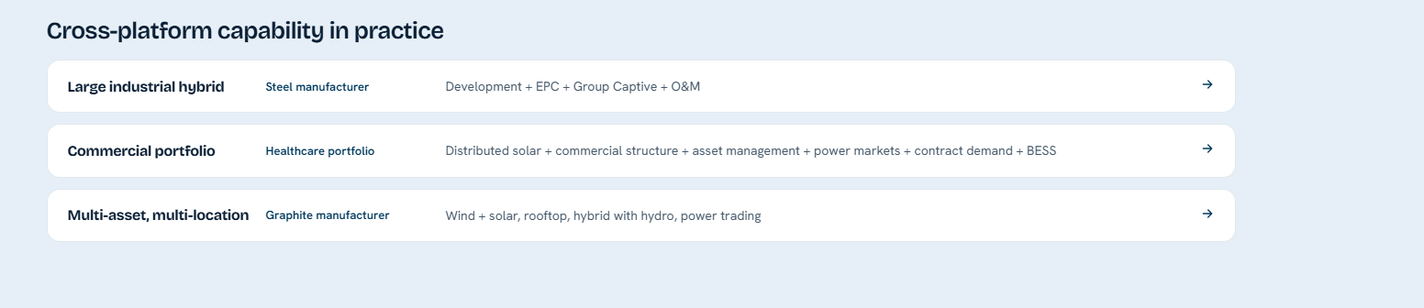
CASE STUDY
- In the Case Study section, instead of the current display format:
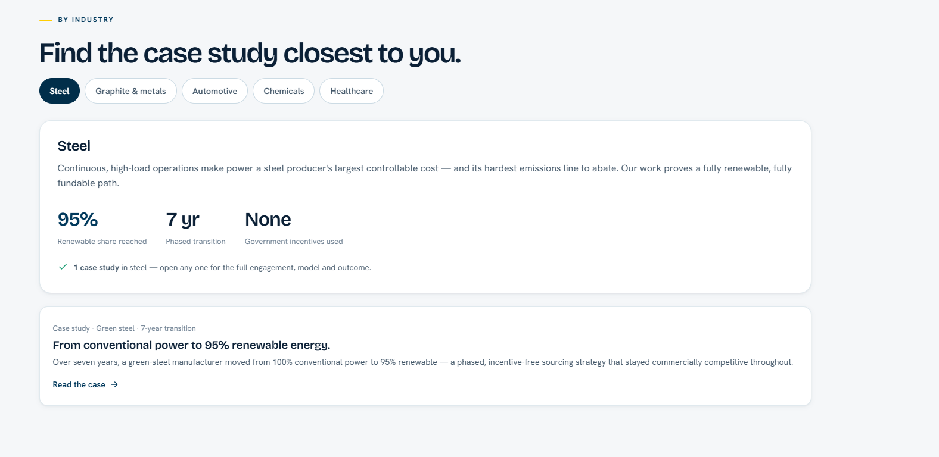
revert to the previous version’s layout, keeping the same content.
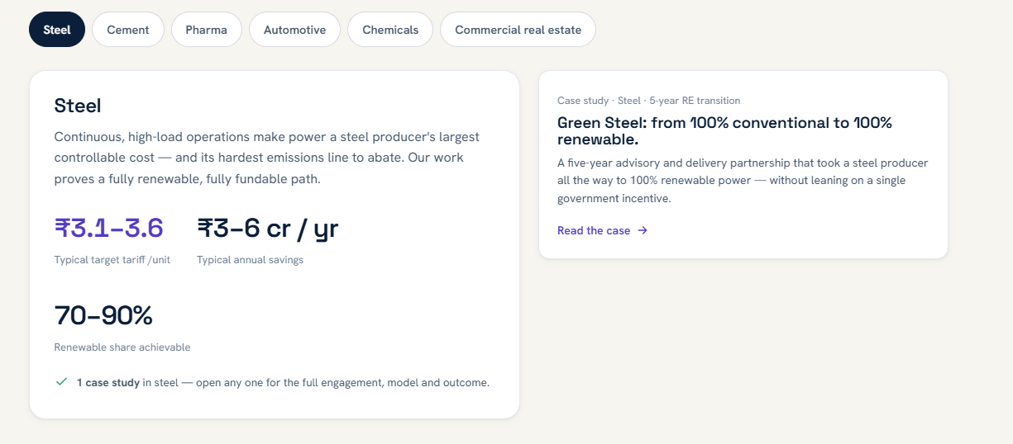
COMPANY

- Change the tagline from “Integrum is building as an energy platform for businesses” to “Integrating Energy Solutions for Businesses.”
- This section can be removed entirely, as the same content already appears elsewhere on the site.
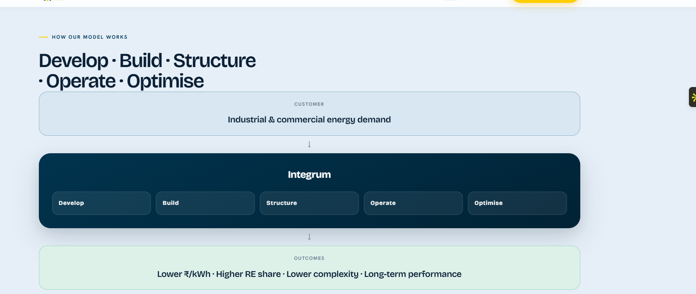
Spacing should be reduced throughout, as the gaps are too large.
- We have three awards that were mentioned on the earlier website; these should be included.
- The heading repeats in the section below; remove the duplicate heading and replace it with “Make to Requisition and Long-Term Partnership.”
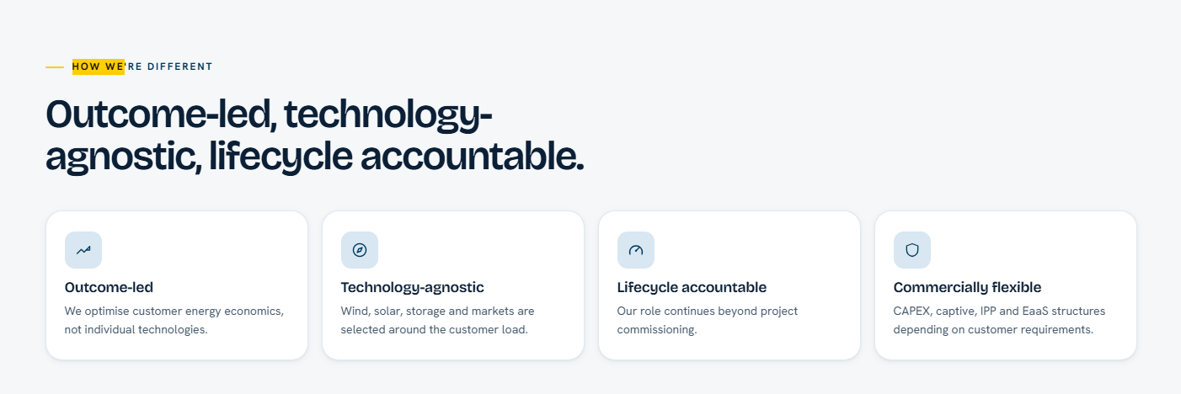
In the heading, replace “Careers” with “People.”
Spacing in these sections is also too wide.
Wherever this image appears across the website, change the shield symbol.
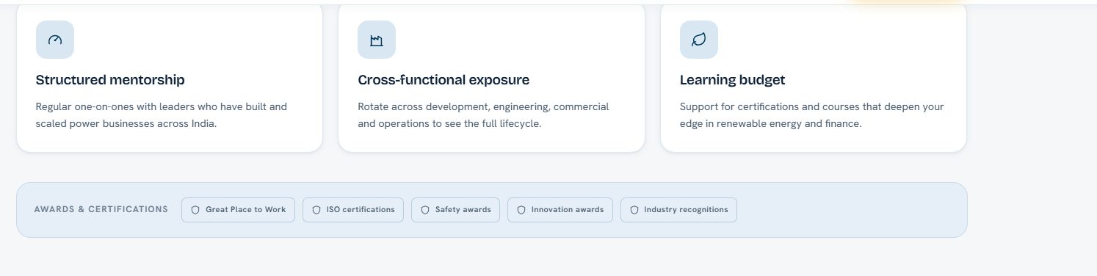
The “Talk to the HR Team” link should automatically open the Contact page with “Talent/Careers” pre-selected, along with an option to upload a resume; the role being applied for should auto-populate as a dropdown sourced from the open positions.
